Specifikacija dizajna stranice za Izraelce 1

Naslovna 2

Hotels (početna pozadina s obzirom da je prvi tab u pitanju) 3

Villa 3

Car 4

Transfer 4

Things to do 4

Navigacija 4

Where? 4

Adriatic 5

Romance 7

Mountain 8

Adrenaline 10

Temper 12

Ostali sadržaj 13

Inputi za tražilicu 13

Hotels 13

Villas 14

Car 14

Transfer 16

Things to do 17

Charter 17

Tekstovi koji se ne vide u dizajnu 18

Mountains 18

# Specifikacija dizajna stranice za Izraelce

Stranica je one-page web, tj sav sadržaj se nalazi na jednoj stranici kroz koju se korisnik naviguje.

Referenti sajtovi:

<https://cleverbirds.com/>

<https://www.banyaksurfadventure.com/#HOME>

[](https://bookingme-my.sharepoint.com/:v:/g/personal/petar_morovic_booking_me/Ecu-jYkPtMFBiwx5rG7XJOUBFfnvFzIXMdA65no0La7Uwg?e=XYGOZG&nav=eyJyZWZlcnJhbEluZm8iOnsicmVmZXJyYWxBcHAiOiJTdHJlYW1XZWJBcHAiLCJyZWZlcnJhbFZpZXciOiJTaGFyZURpYWxvZy1MaW5rIiwicmVmZXJyYWxBcHBQbGF0Zm9ybSI6IldlYiIsInJlZmVycmFsTW9kZSI6InZpZXcifX0%3D)

## Naslovna

* Full screen slika sa transparent tražilicom
* Poruka iznad tražilice: *Your way to Montenegro*
* Naslov da bude stilizovan u pisanom obliku
* Primjer:

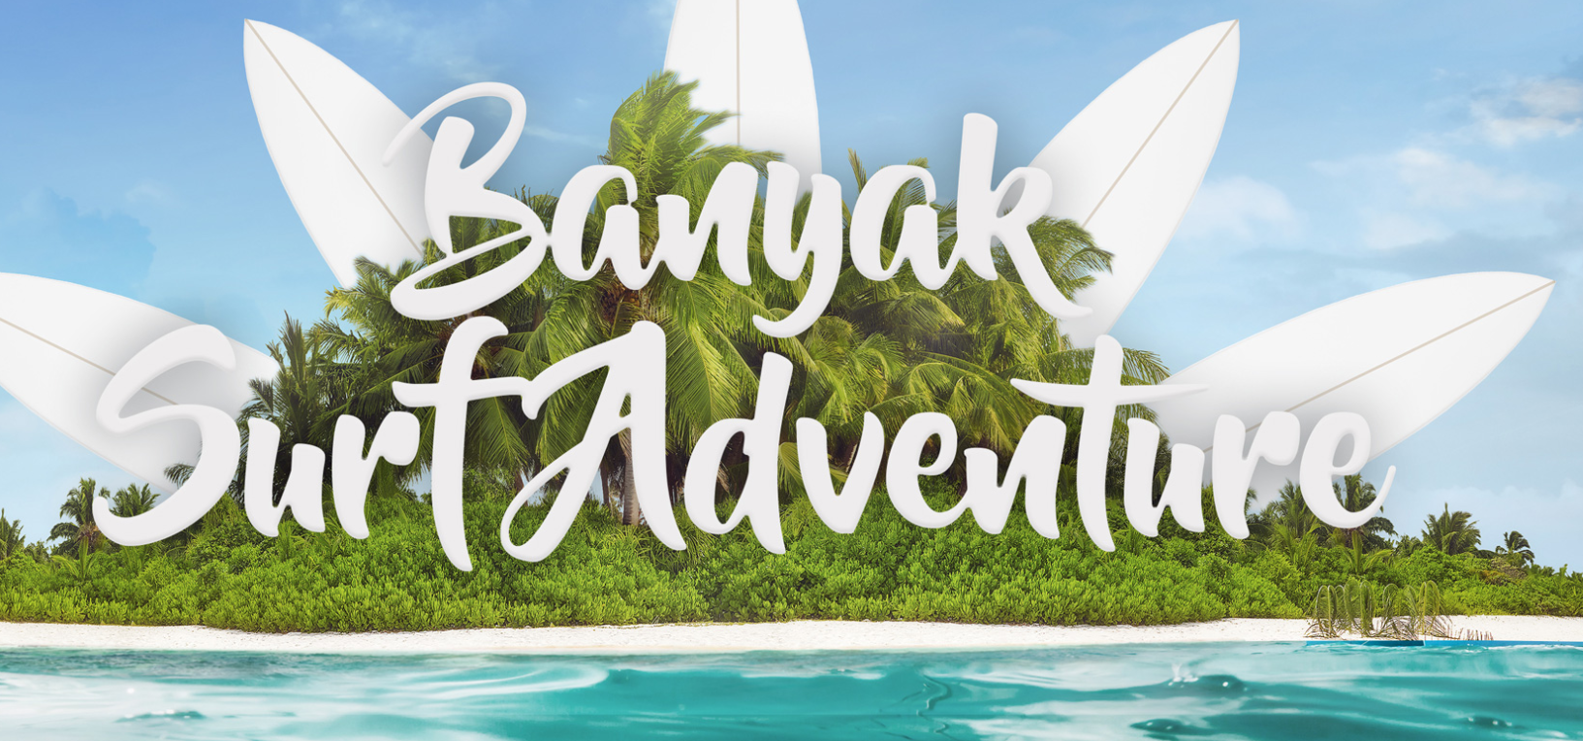

* Svaki tab tražilice ima svoju pozadinu

### Hotels (početna pozadina s obzirom da je prvi tab u pitanju)

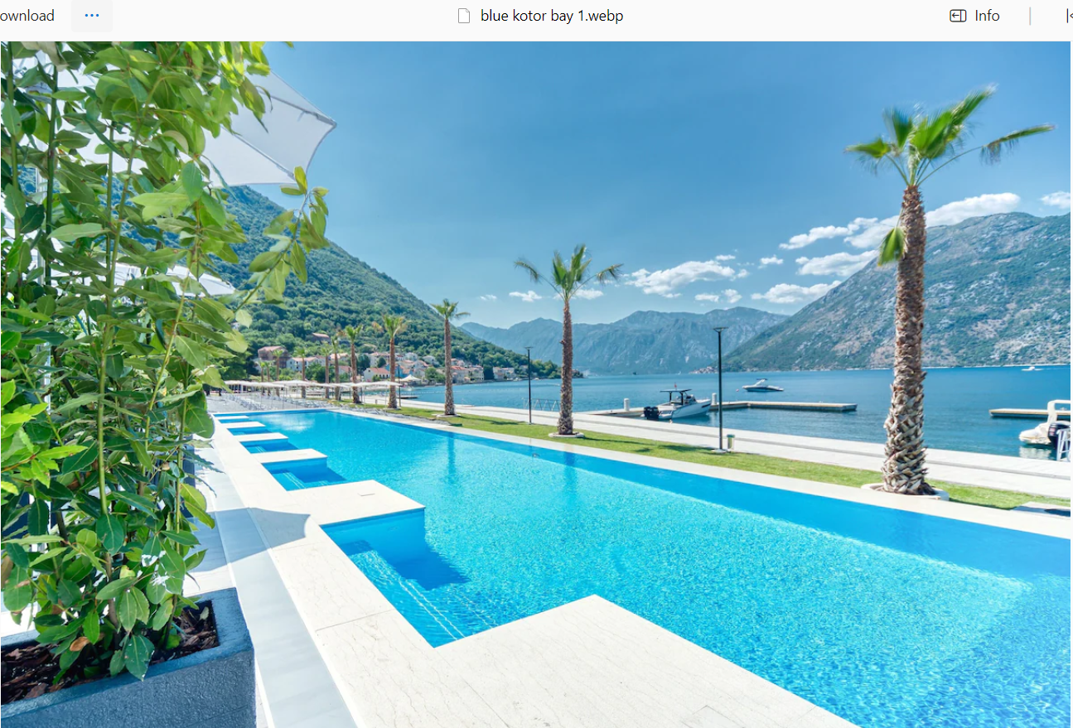

### Villa

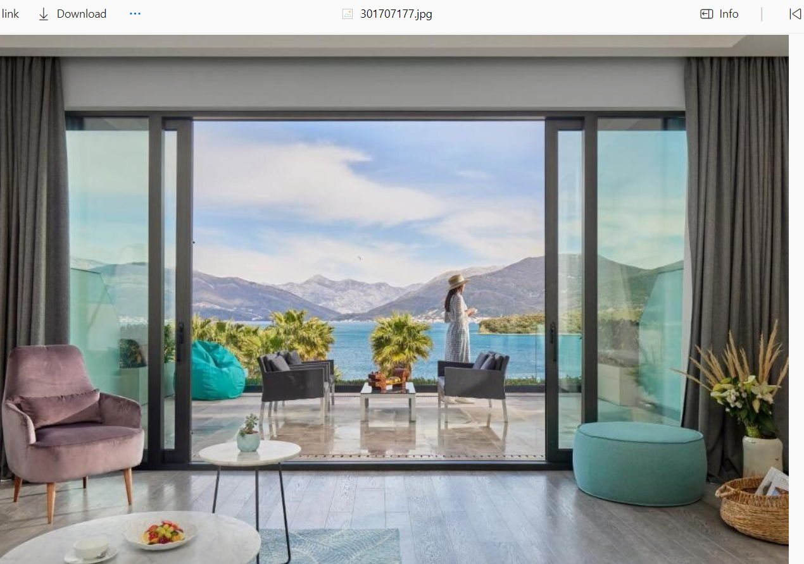

### Car

Npr neku od onih mazdinih profi slika koje smo koristili za long term, ili nešto treće bolje što nađeš. Pejzaž treba da bude u prvom planu, ne auto

### Transfer

Mercedes Minivan negdje na putu kroz CG, najbolje da bude neki prirodni krajolik. Moguće da imaju a moguće da ćeš morati naći.

### Things to do

Neku dobru pozadinu od najpoznatijih aktivnosti u CG. Ili obilazak starih gradova, ili kajt surfovanje, ili kanjoning, ili nešto treće. Valjalo bi da sadrži ekspresivna lica ljudi u tim aktivnostima

## Navigacija

Kada se otvori stranica, na dnu je, ispod tražilice, a kako se skroluje ka dolje, prelazi na vrh i tu ostaje. Potpuno je providna sem kada je krusor na njenim elementima kada dobija sivi kontrast. Obratiti pažnju na efekte prema referentnom primjeru: <https://cleverbirds.com/>

Stavke u navigaciji su:

* Where?
* Adriatic
* Romance
* Mountain
* Adrenaline
* Temper

Centralna stavka u obliku tastera je book (koja vraća na tražilicu).

## Where?

Pozadina sa obrisima CG na mapi. Što manje kontura, što svjetlije polje. Tekst je na pozadini. Primjer dobrog naslova:



Tekst:

*Montenegro is a captivating country in Southeastern Europe, nestled along the stunning Adriatic Sea. Its diverse landscape features a breathtaking coastline with gems like the Bay of Kotor, often referred to as Europe's southernmost fjord. Coastal towns like Kotor, Budva, and Herceg Novi showcase medieval architecture, charming old towns, and vibrant nightlife.*

*Inland, you'll find the majestic Lovćen and Durmitor mountain ranges, hosting Lovćen National Park and Durmitor National Park. These areas boast rugged landscapes, deep canyons, and dense forests, providing a haven for outdoor enthusiasts with activities such as hiking, rafting, and winter sports.*

*Montenegro is home to cultural treasures like the Ostrog Monastery, perched on a vertical cliff, and historical sites such as the ancient town of Stari Bar. The country's largest lake, Skadar, straddles the border with Albania and is known for its diverse ecosystem, making it a haven for birdwatchers and nature lovers.*

*Overall, Montenegro's harmonious blend of natural beauty, historical charm, and cultural richness makes it a must-visit destination for any traveler.*

Referenca:



## Adriatic

Isti tip naslova kao i za Where? (odavde nadalje takođe za ostale sekcije...ako misliš da možeš, možeš svaki da stilizuješ posebno)

Ova sekcija ima slajder na nekih 2/3 širine a tekst na 1/3. Slika koju sam priložio neka bude prva, a ostale su ispod. Ti možeš naravno da ih nađeš još

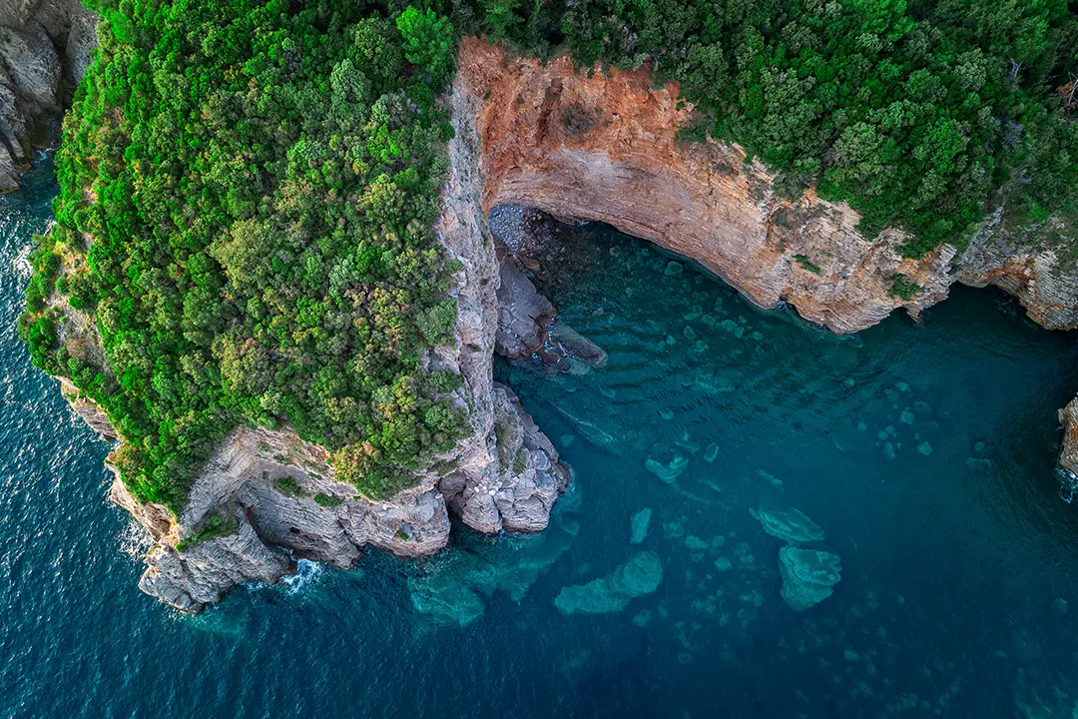

<https://petar.boats/sr/redovni-izleti/zanjice-i-plava-spilja-izlet-brodom>

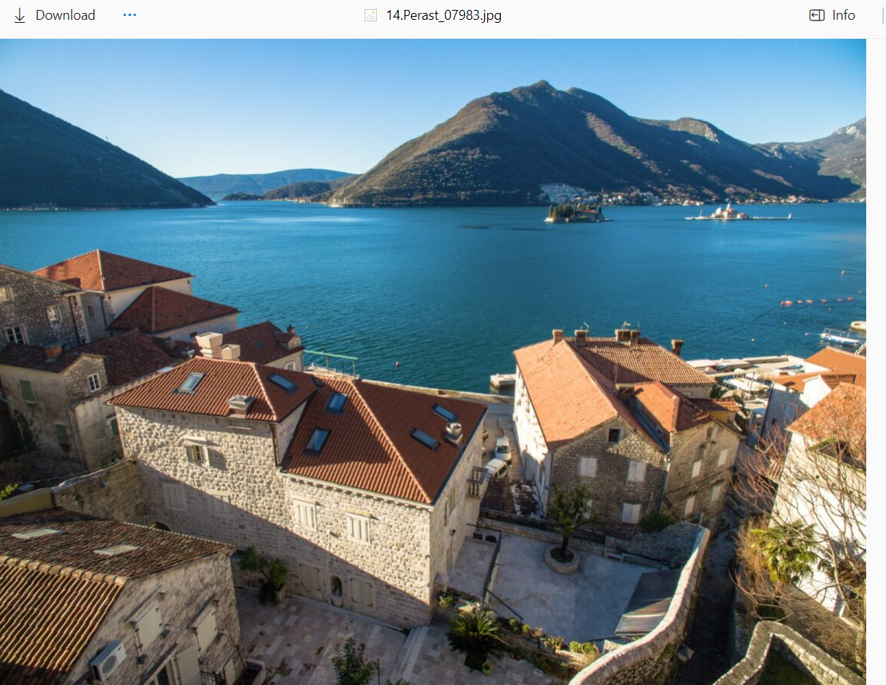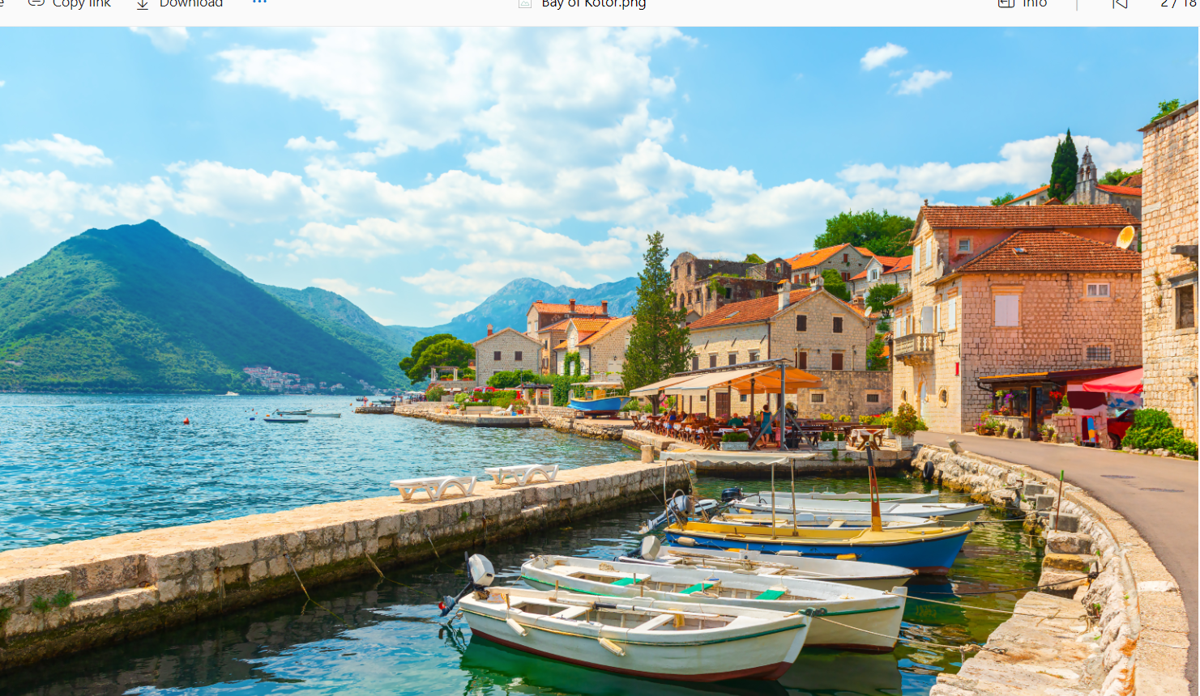

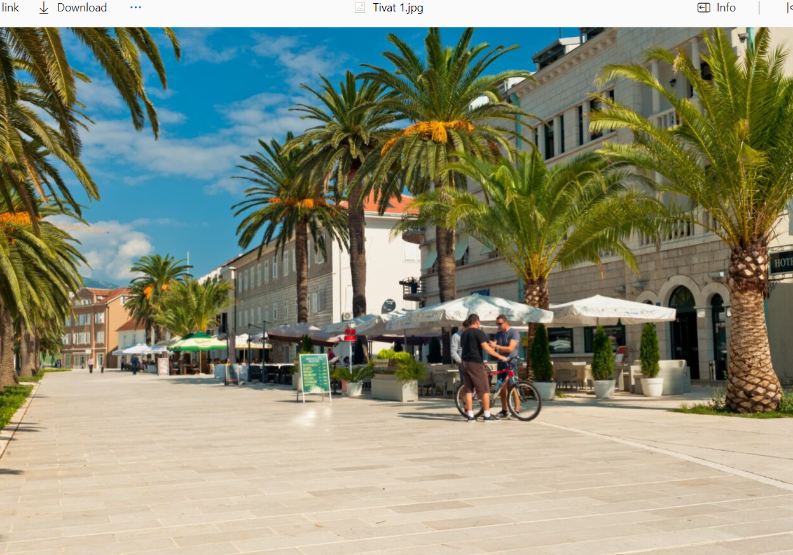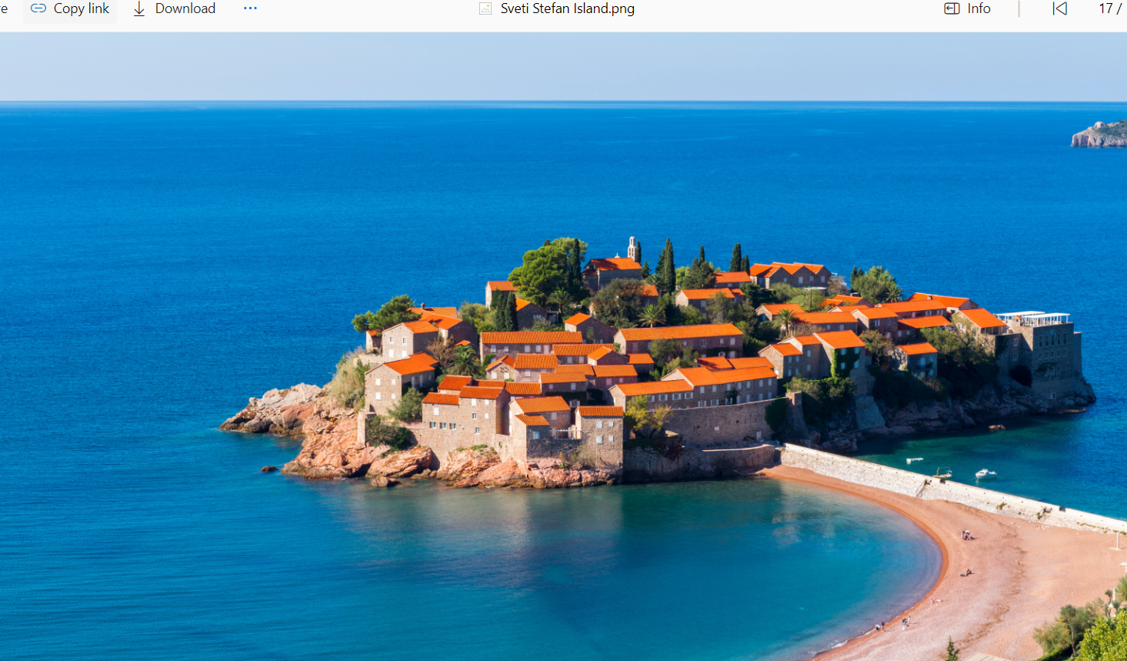

Tekst:

*Embark on an enchanting voyage across the sparkling Adriatic Sea, unveiling the treasures that grace the Montenegrin coastline. The gentle sway of charter boats introduces you to a world where each wave carries tales of hidden coves and picturesque fishing villages. As you sail along the shores, the ancient towns of Kotor and Budva emerge like time-worn jewels, steeped in history and surrounded by the splendor of the Adriatic. Snorkel in crystalline waters, bask in the Mediterranean sun, and indulge in the delectable local seafood. The coastal allure, complemented by Montenegro's warm hospitality, creates a seamless fusion of past and present, making this Adriatic adventure a sojourn into a realm where time dances with the rhythm of the sea.*

Referenca:

(napomena da tekst ide sa strane a ne ispod kao na primjeru)

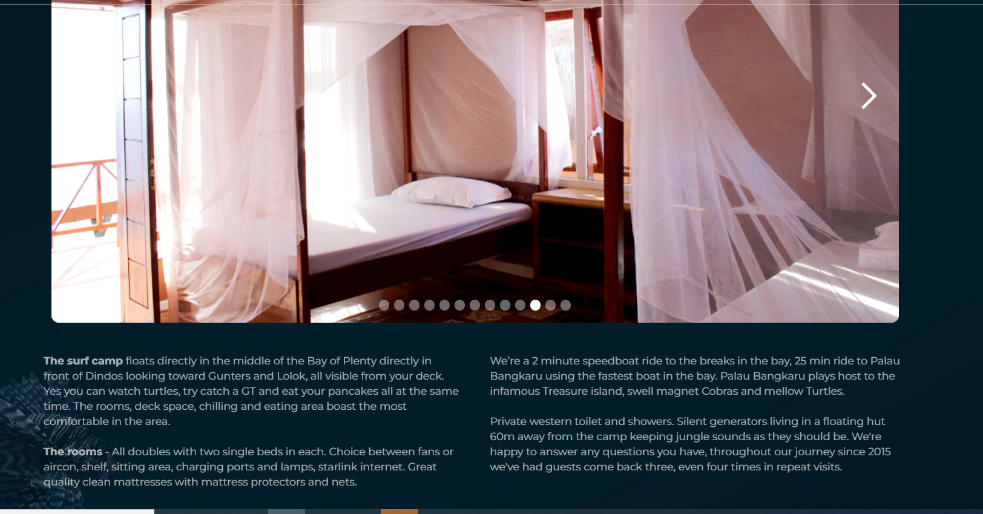

## Romance

Samo dvije slike. Poželjno je da jedna bude romantični par varijanta, a druga vjenčanje varijanta. Zalazak bi bio poželjan na obje fotografije, sa nekim atraktivnim krajolikom u CG. Motiv na slici ispod čisto kao inspiracija a ako se ne nađu zalasci, može biti iskorišćen kao jedna od dvije slike.

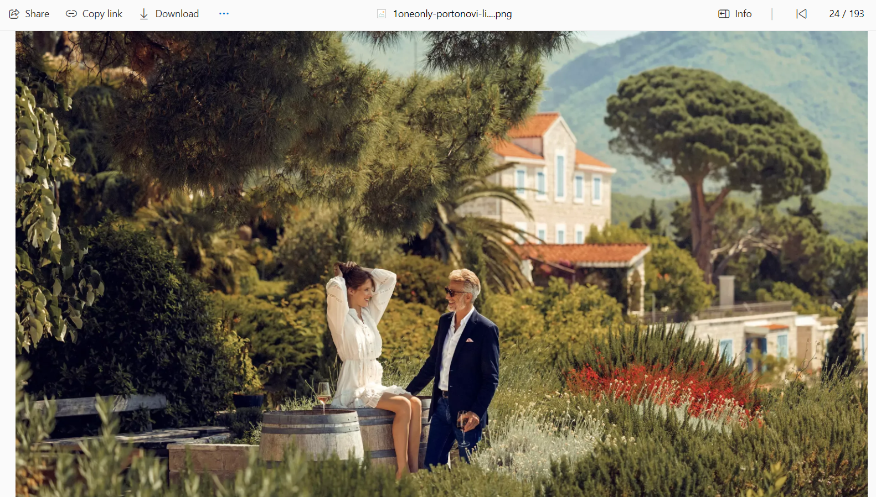  
Naslov ide preko obje slike, a hover pravi kontrast za naslov na slici koja nije hoverovana, a prikazuje sliku koja je hoverovana

Referenca:



## Mountain

Slično kao za Adriatic, samo da galerija bude full screen. Tekst je u slici na pogodnom mjestu. I kako se mijenjaju slike, da se mijenja i tekst. Biće ispisano 5 planina, znači ide 5 slika. Meni je ova slika Komova najbolja. Za ostale biraj, ja sam našao neke predloge u galeriji mts, i mislim da su dobre (nemam Prokletije ovdje, ni Durmitor)

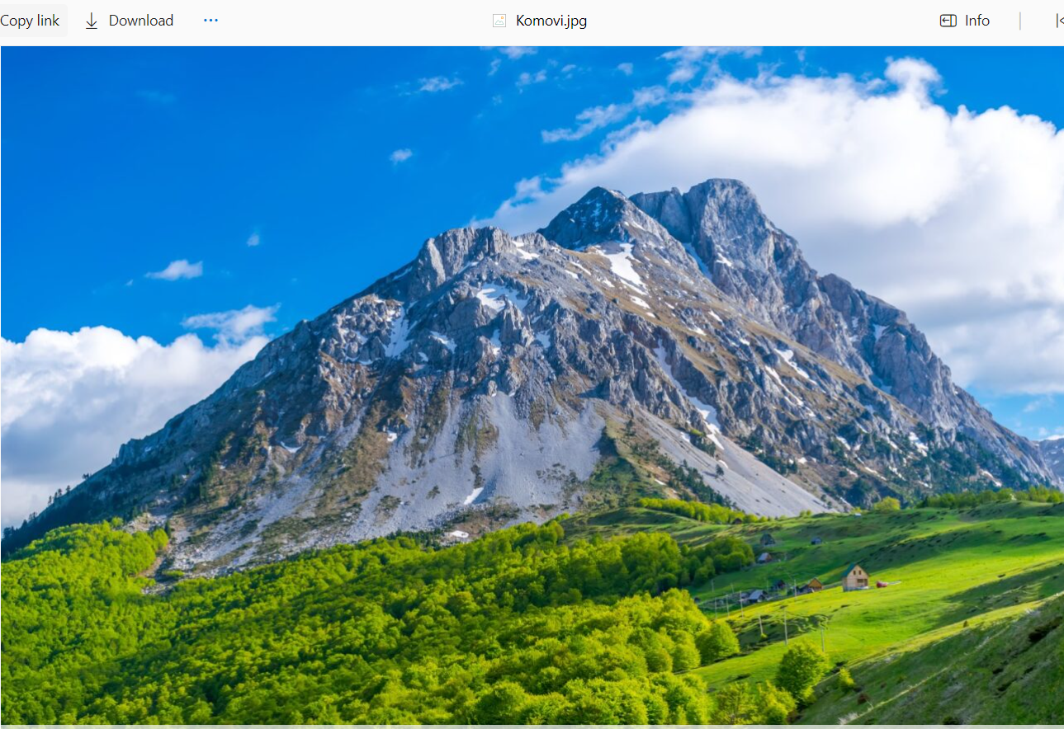

Tekst za svaku:

*Durmitor:*

*Nestled in the northwest, the Durmitor Range tells a story etched in stone. Its craggy peaks, like sentinels of time, guard the entrance to the UNESCO World Heritage site – Durmitor National Park. There, beneath the towering Bobotov Kuk, adventurers embark on journeys through deep canyons and encounter crystalline glacial lakes reflecting the drama of the Dinaric Alps.*

*Lovćen:*

*Closer to the Adriatic's embrace, the Lovćen Range unfolds its rocky tapestry. As the coastal winds whisper tales of old, Lovćen National Park unveils Mount Lovćen, a sacred peak offering a panoramic theater of the Bay of Kotor. At its summit, the Njegoš Mausoleum stands as a testament to Montenegro's history and the poetic spirit of Petar II Petrović Njegoš.*

*Komovi:*

*In the northeastern reaches, the Komovi Mountains beckon with alpine allure. Kom Kučki, Kom Vasojevićki, and Kom Ljevoriječki, the trilogy of peaks, guard the secrets of their scenic landscapes. Hiking through these summits reveals vistas that blur the lines between earth and sky.*

*Prokletije (Accursed Mountains):*

*Straddling borders and defying expectations, the Prokletije, or Accursed Mountains, rise with rugged determination. Here, the landscape is a symphony of peaks, valleys, and glacial lakes. Maja Jezerce, the crown jewel, presides over this untamed realm, inviting adventurers to explore its majestic slopes.*

*Bjelasica:*

*In the heartland of Montenegro, the Bjelasica Range paints a different tale. Rolling hills, dense forests, and alpine meadows set the stage. Within Biogradska Gora National Park, the whispering leaves of one of Europe's last primeval forests tell stories of resilience. Biogradsko Lake, a mirror of tranquility, reflects the rich biodiversity that thrives in this ancient realm.*

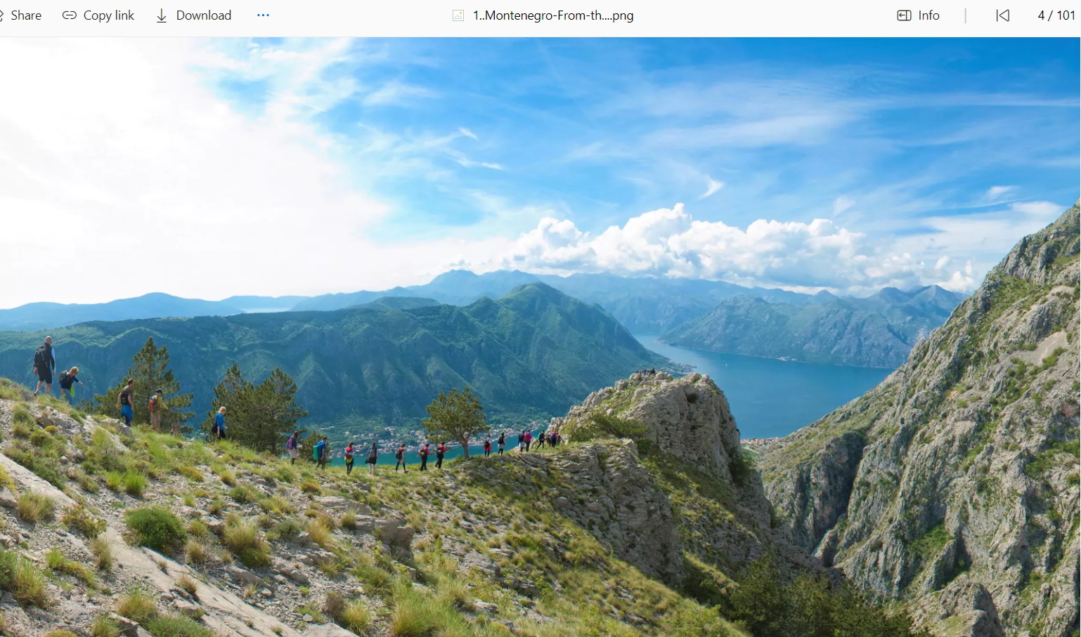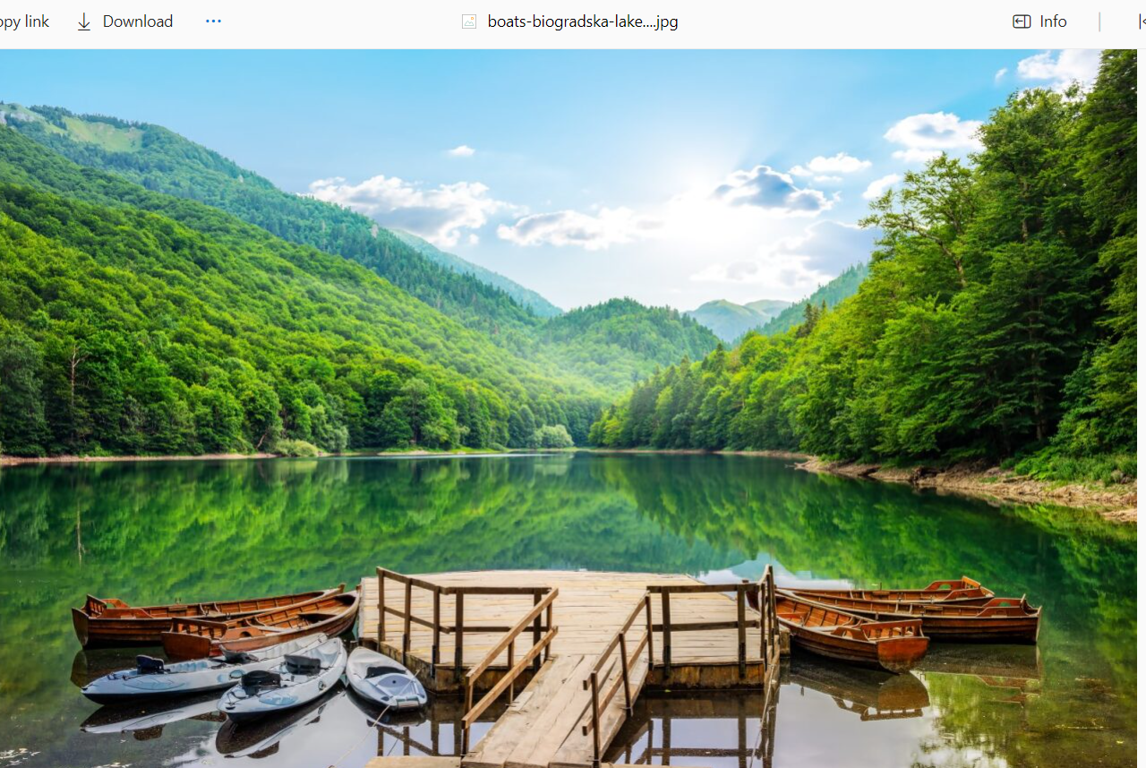

## Adrenaline

4 slike izdijeljene ravnopravno za 4 ekstremne aktivnosti: rafting, kanjoning, kite surfing, paragliding (ili neka druga umjesto paragliding-a)

Za svaku naći odgovarajuće slike. Hover preko slike zamagljuje sliku i otvara tekst.

Tekst:

*Rafting:*

*In Montenegro, the meandering rivers offer thrilling rafting experiences amidst stunning landscapes. The Tara River Canyon, Europe's deepest canyon, is a haven for rafting enthusiasts. The journey down the Tara River, known as the "Tear of Europe," is a rush of adrenaline as you navigate through crystal-clear waters, sheer cliffs, and untouched wilderness. The Tara River is renowned for its challenging rapids and breathtaking scenery, making it a must-try adventure for those seeking an exhilarating rafting experience.*

*Canyoning:*

*Montenegro's diverse topography creates a playground for canyoning enthusiasts. The canyons, carved by rivers and time, provide a natural adventure course. The Nevidio Canyon, known as the "Unseen Canyon," is a popular canyoning destination. Exploring this narrow gorge involves rappelling down waterfalls, swimming through crystal-clear pools, and navigating the dramatic rocky terrain. Canyoning in Montenegro is not only an adrenaline-pumping activity but also an opportunity to immerse yourself in the untouched beauty of the country's canyons.*

*Kite Surfing:*

*For water sports enthusiasts, Montenegro's Adriatic coastline beckons with ideal conditions for kite surfing. Spots like Ulcinj and Ada Bojana are known for their consistent winds and wide sandy beaches, providing the perfect setting for kite surfing adventures. Beginners can take lessons from local instructors, while experienced kite surfers can enjoy the thrill of riding the waves and feeling the wind under their kites against the backdrop of Montenegro's picturesque coastal scenery.*

*Paragliding:*

*For those seeking the ultimate aerial adventure, paragliding in Montenegro offers breathtaking views of the mountains, lakes, and coastline. Locations like Žabljak, nestled in the Durmitor National Park, provide a surreal backdrop for paragliding. Take to the skies and soar over pristine landscapes, experiencing a sense of freedom as you glide above the rugged mountain terrain or descend towards the serene beauty of Lake Skadar. Tandem flights with experienced pilots are available for those new to paragliding, offering a unique perspective of Montenegro's natural wonders.*

Primjeri slika:

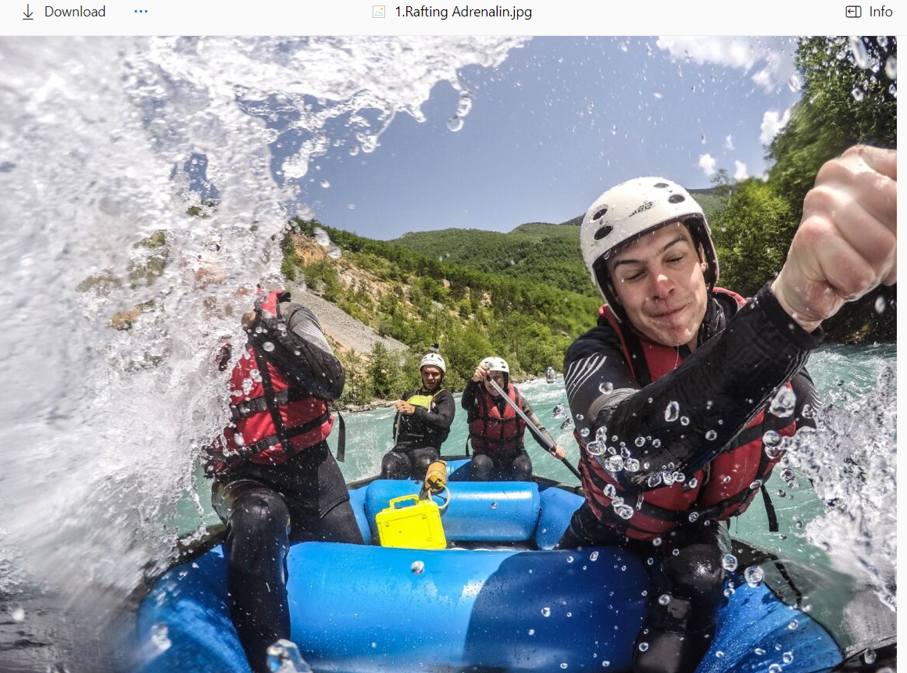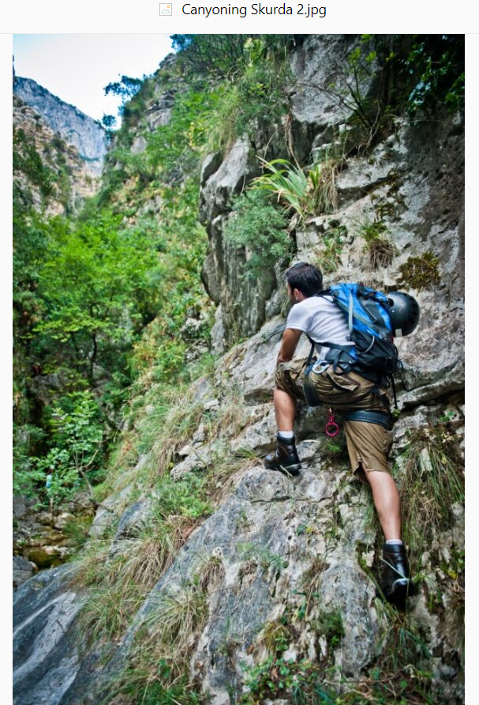

Referenca (samo umjesto ikona, idu slike u punom planu, tj ¼ ekrana)



## Temper

Kolaž slika. Hover preko jedne je zamagljuje i prikazuje o čemu se radi. Ubaciti sve i svašta, narod, nošnju, tradiciju, hranu, vino itd, od svega po malo

Referenca (bar 3-4 reda sličica)

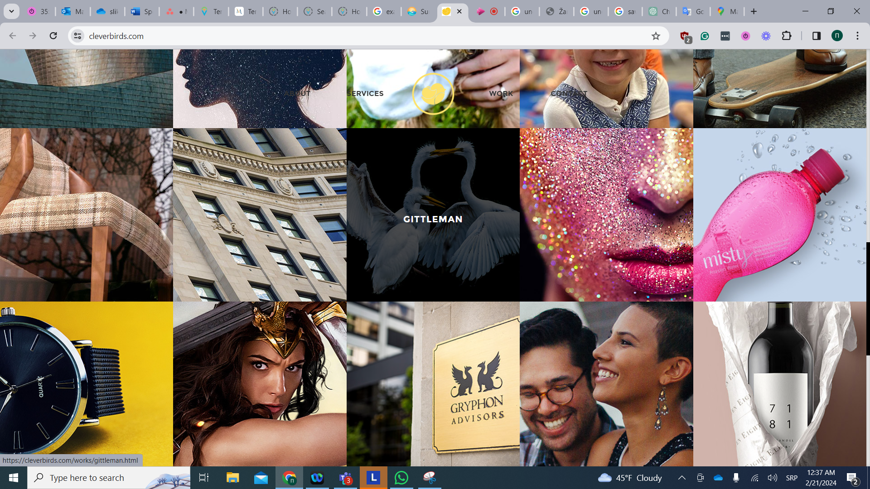

# Ostali sadržaj

## Inputi za tražilicu

### Hotels

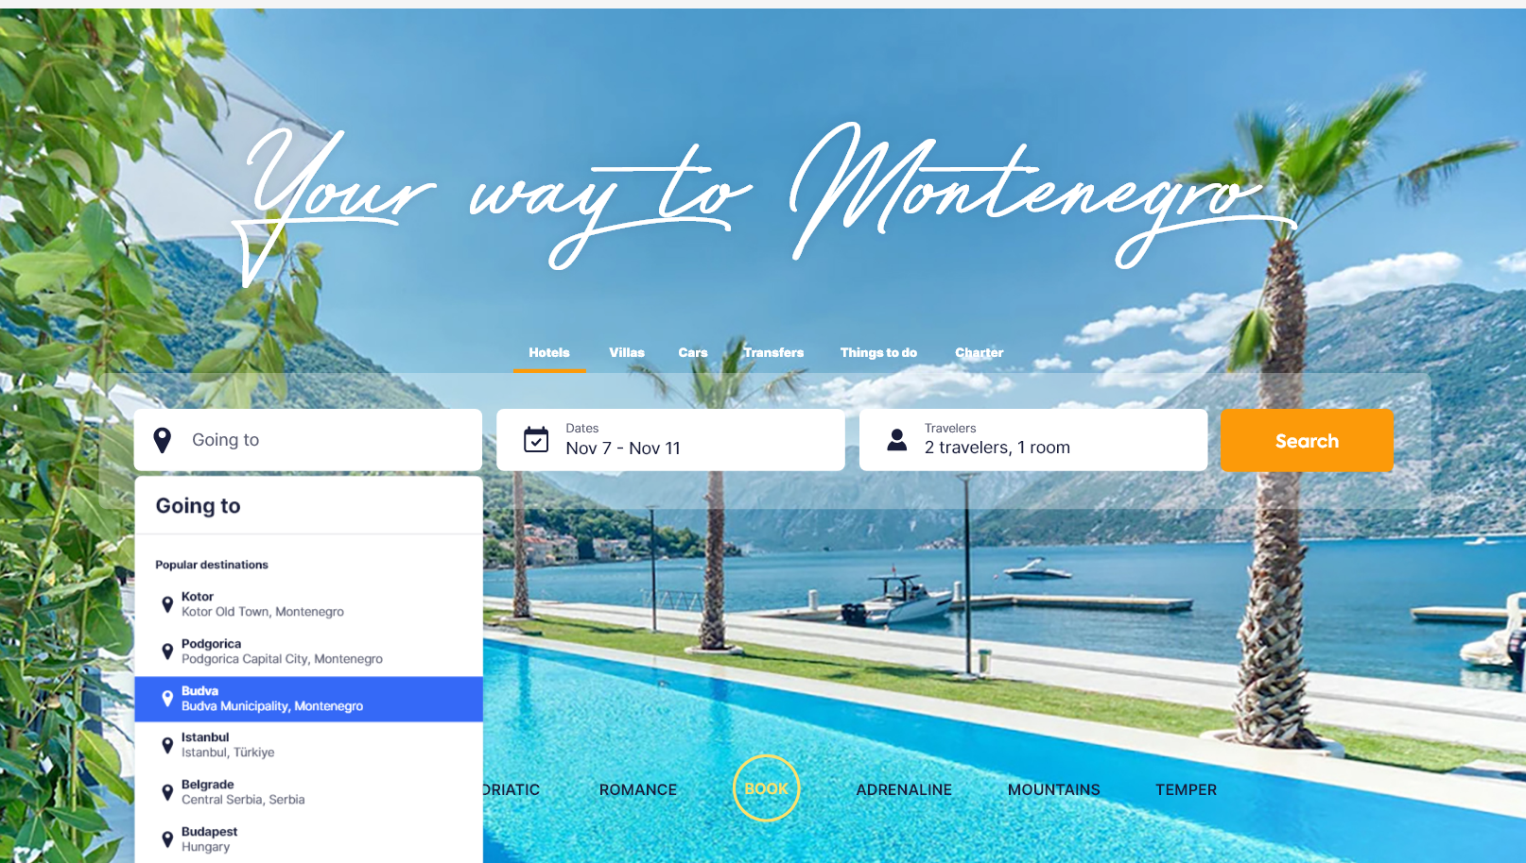

N/A

### Villas

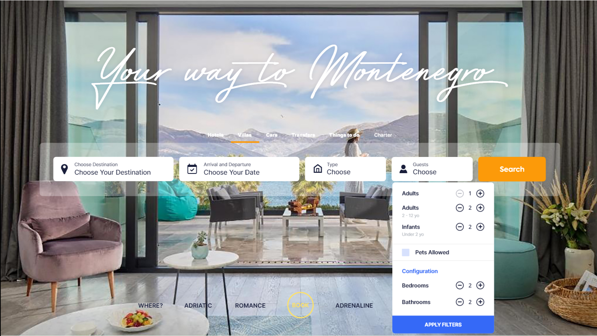

Location:

* Bay of Kotor
* Budva
* Tivat
* Kotor
* Herceg Novi
* Bar
* Petrovac
* Ulcinj
* Podgorica
* Montenegro Coastline
* Montenegro North
* Central Montenegro

Ostalo je sve kao na <https://montenegrovillas.com/en>

### Car

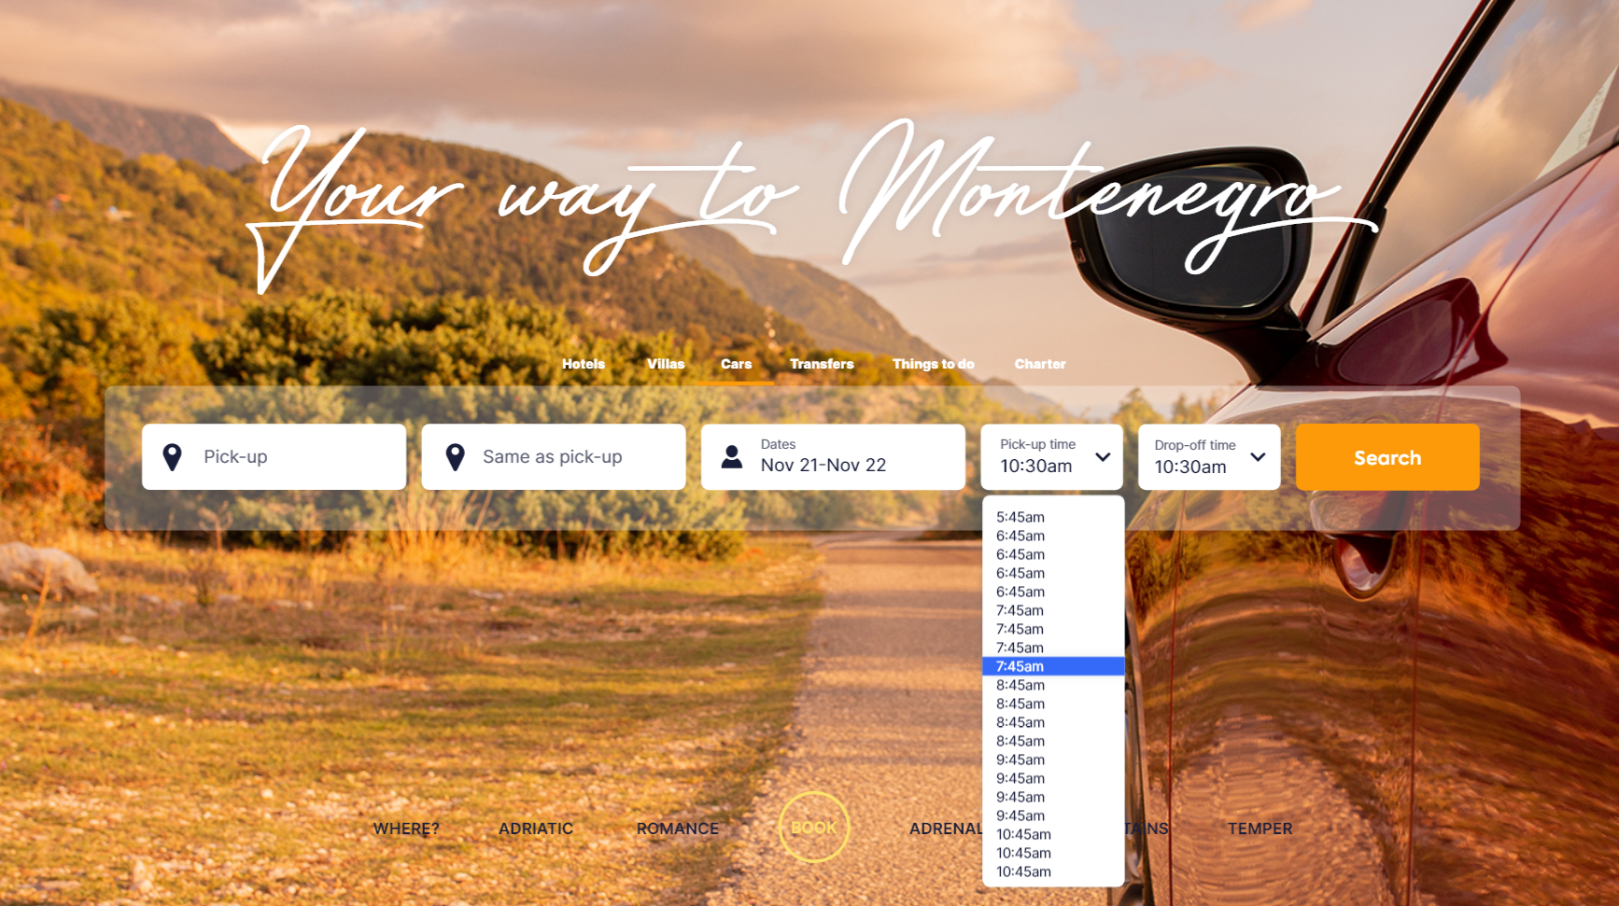

Pickup:

Agregira locations i meet&greet. Umjesto naziva u linku su primjećeni ID-ovi, pa su ovdje i priloženi. ID-ovi za meet&greet idu u kombinaciji sa locations ID (za koju je meet&greet vezan)

* Locations
  + 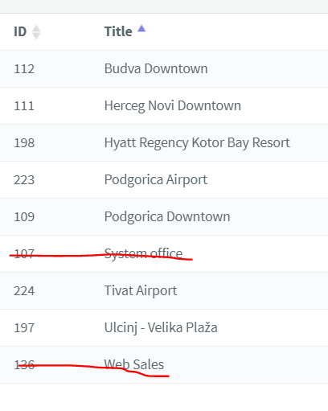
* Meet&Greet
  + Tivat Airport (TIV)
    - 205 Tivat Bus Station
    - 208 Porto Montenegro
    - 211 Nikki Beach Tivat
  + Budva Downtown
    - 118 Petrovac - Hotel Palas
    - 180 Becici
    - 206 Bip Hotel
    - 213 Iberostar Bellevue
  + Herceg Novi Downtown
    - 207 Portonovi Resort
    - 210 Lazure hotel Meljine
    - 218 Iberostar
    - 220 Bijela
  + Hyatt Regency Kotor Bay Resort
    - 181 Kotor Downtown
    - 212 Huma Kotor Bay Hotel & Villas
    - 216 Kotor Marina
    - 219 Prčanj
    - 223 Villa Shah
  + Podgorica Downtown
    - 172 Bar
    - 173 Kolasin
    - 214 Hotel Crnogorska Kuća
    - 215 Hotel Lazaro
    - 221 Hotel Keto
    - 222 Hotel Hilton

Time pickup i dropoff je na pola sata, 0-24, kao na <https://www.montenegrocar.me/>

### Transfer

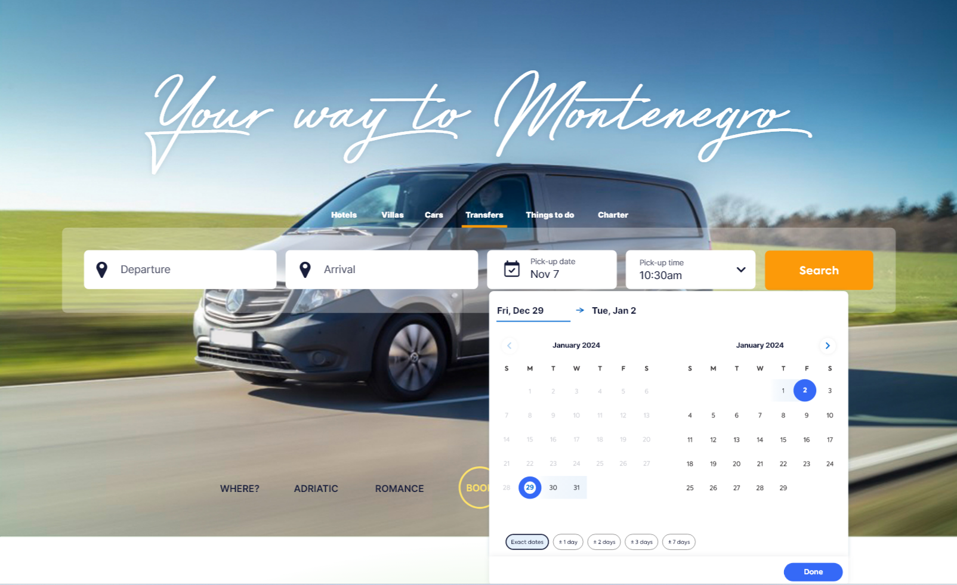

Departure & Arrival:

* Tirana
* Airport Podgorica (TGD)
* Airport Tivat (TIV)
* Petrovac
* Kolašin
* Airport Dubrovnik (DBV)
* Dubrovnik
* Airport Tirana (TIA)
* Durmitor/Žabljak
* Monastery Ostrog
* Skadar Lake
* Bar
* Kotor
* Perast
* Cetinje
* Herceg Novi
* Tivat
* Ulcinj
* Budva
* Podgorica

### Things to do

* All attributes

### Charter

* 
* 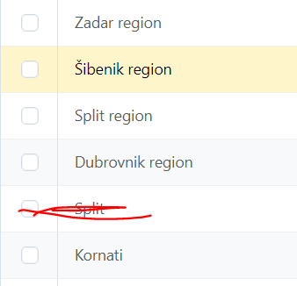

## Tekstovi koji se ne vide u dizajnu

### Mountains

*Durmitor:*

*Nestled in the northwest, the Durmitor Range tells a story etched in stone. Its craggy peaks, like sentinels of time, guard the entrance to the UNESCO World Heritage site – Durmitor National Park. There, beneath the towering Bobotov Kuk, adventurers embark on journeys through deep canyons and encounter crystalline glacial lakes reflecting the drama of the Dinaric Alps.*

*Lovćen:*

*Closer to the Adriatic's embrace, the Lovćen Range unfolds its rocky tapestry. As the coastal winds whisper tales of old, Lovćen National Park unveils Mount Lovćen, a sacred peak offering a panoramic theater of the Bay of Kotor. At its summit, the Njegoš Mausoleum stands as a testament to Montenegro's history and the poetic spirit of Petar II Petrović Njegoš.*

*Komovi:*

*In the northeastern reaches, the Komovi Mountains beckon with alpine allure. Kom Kučki, Kom Vasojevićki, and Kom Ljevoriječki, the trilogy of peaks, guard the secrets of their scenic landscapes. Hiking through these summits reveals vistas that blur the lines between earth and sky.*

*Prokletije (Accursed Mountains):*

*Straddling borders and defying expectations, the Prokletije, or Accursed Mountains, rise with rugged determination. Here, the landscape is a symphony of peaks, valleys, and glacial lakes. Maja Jezerce, the crown jewel, presides over this untamed realm, inviting adventurers to explore its majestic slopes.*

*Bjelasica:*

*In the heartland of Montenegro, the Bjelasica Range paints a different tale. Rolling hills, dense forests, and alpine meadows set the stage. Within Biogradska Gora National Park, the whispering leaves of one of Europe's last primeval forests tell stories of resilience. Biogradsko Lake, a mirror of tranquility, reflects the rich biodiversity that thrives in this ancient realm.*